EXP 18
Aim
To detect edges using the Sobel operator along the Y-axis.
Procedure
- Read the image.
- Convert to grayscale.
- Apply Sobel along the Y-axis.
- Display the result.
Code
import cv2
img = cv2.imread("image1.png")
gray = cv2.cvtColor(img, cv2.COLOR_BGR2GRAY)
sobely = cv2.Sobel(gray, cv2.CV_64F,0,1,ksize=3)
cv2.imshow("Sobel Y", sobely)
cv2.waitKey(0)
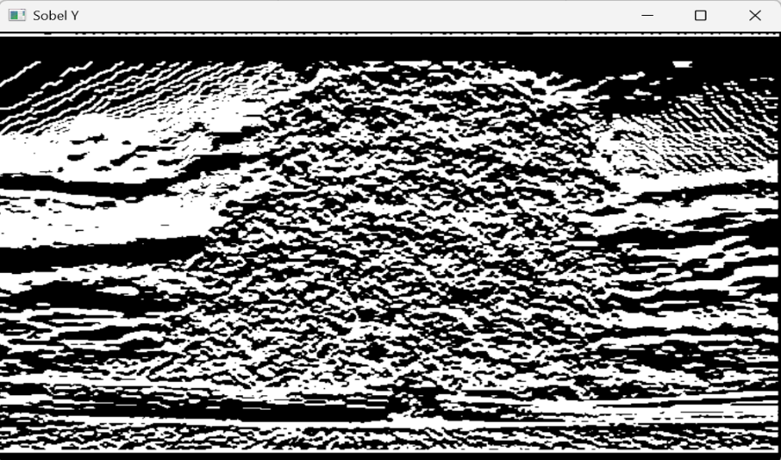
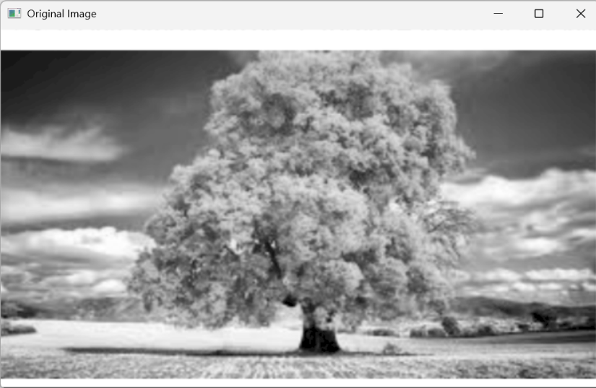
cv2.destroyAllWindows()

